BACHELOR STUDENT TOOLKIT
Python Mid-Term Project Report

Project Title | Bachelor Student Toolkit
Module Covered in This Report | Expense Tracker (my individually completed part)
Student Name | Jannatun Fardous
Student ID | 21-45527-3
Course / Section | Programming in Python [Section: D]
Instructor | MD. TANZEEM RAHAT
Date of Submission | 27 July 2026
Note: This is a group project split into four modules (Student Profile & Academic Records, Class Routine & Exam Schedule, Expense Tracker, Study Planner). This report documents only the Student Profile & Academic Records module, which is complete. The remaining three modules are being developed by teammates and are marked as PENDING throughout this report; sections describing them will be completed once those modules are finished.

1. Project Title and Group / Member Information
Project Title: Bachelor Student Toolkit — a console-based application that helps a bachelor's-degree student manage their academic profile and records in one place.
Module | Responsible Member | Status
Student Profile & Academic Records | [Teammate name — pending] | pending
Class Routine & Exam Schedule | [Teammate name — pending] | Pending
Expense Tracker | Jannatun Fardous | complete
Study Planner | [Teammate name — pending] | Pending

2. Problem Statement and Objectives

Problem Statement

The Student Assistant System – Expense Tracker is a Command-Line Interface (CLI) application developed using Python to help students manage their daily expenses efficiently. The system allows users to record expenses, view all expense records, and calculate the total amount spent. All expense data is stored permanently in a CSV file, ensuring that records are preserved even after the application is closed.
Track: CLI Project
Programming Language: Python 3
Data File: expenses.csv
University students often spend money on food, transportation, books, stationery, internet packages, and other daily necessities. Keeping track of these expenses manually can be difficult and may lead to poor budgeting and unnecessary spending. Students need a simple system that helps them record and monitor their expenses in an organized manner.
The Expense Tracker module solves this problem by providing a user-friendly command-line application that enables users to add new expenses, view all recorded expenses, and calculate the total amount spent. The application stores all information in a CSV file using Python's file handling features, allowing data to remain available for future use.

Objectives
The main objectives of this module are:
- To record daily student expenses.
- To store expense information permanently using a CSV file.
- To display all saved expenses in a well-formatted table.
- To calculate and display the total amount spent.
- To provide a simple, easy-to-use command-line expense management system.

3. Feature List and Target Users

Target Users
- University students
- College students
- Anyone who wants to keep track of daily expenses

3.1 Implemented Features
No. | Feature | Description
1 | Add Expense | Allows users to enter the date, expense category, amount, and description. If no date is entered, the current date is used automatically.
2 | View All Expenses | Displays all recorded expenses in a well-formatted table showing the date, category, amount, and description.
3 | View Total Spent | Calculates the total amount of all recorded expenses and displays it to the user.
4 | CSV File Storage | Stores all expense records permanently in the expenses.csv file so that data is not lost after the program is closed.
5 | Menu-Based Navigation | Provides a simple menu-driven interface that allows users to navigate between different options easily.

4. Explanation of Used Python Concepts (Week 1–5)
Concept | Where It Is Used in the Expense Tracker Module
Variables & Data Types | Used to store expense information such as date, category, amount, and description. Data types include String, Float, List, and Dictionary.
Operators | Arithmetic operators are used to calculate the total amount spent. Assignment, comparison, and logical operators are used throughout the program.
Conditional Statements (if / elif / else) | Used to validate user input, process menu selections, and display appropriate messages for valid or invalid choices.
Loops (while / for) | The while loop keeps the menu running until the user exits. The for loop is used to display all expense records from the CSV file.
Functions | Separate functions are created for each task such as adding expenses, viewing expenses, calculating total expenses, initializing the CSV file, and displaying the menu.
File Handling | Python's CSV module is used to read and write expense records, ensuring permanent data storage.
Exception Handling | The try-except block is used to handle invalid amount input and prevent the program from crashing.

5. Data Structure Explanation: List, Tuple, Set, Dictionary
Data Structure | Example in Code | Purpose
List | rows = list(reader) | Stores all expense records read from the CSV file so they can be displayed in a table.
Tuple | Not used in this module. | This module does not require a tuple because there is no fixed collection of values.
Set | Not used in this module. | A set is not required since duplicate expense categories are allowed.
Dictionary | csv.DictReader(file) | Reads each expense record as a dictionary with keys such as Date, Category, Amount, and Description, making the data easy to access.

6. Program Design and Function Explanation
The Expense Tracker module follows a function-based modular design. Each function performs a specific task, making the program organized, reusable, and easy to maintain.
Function Name | Description
init_csv() | Creates the expenses.csv file with the required column headers if it does not already exist.
add_expense() | Accepts expense details (date, category, amount, and description) from the user and stores them in the CSV file.
view_expenses() | Reads all expense records from the CSV file and displays them in a well-formatted table.
view_total() | Calculates the total amount spent by reading all expense records and summing their amounts.
expense_tracker_menu() | Displays the Expense Tracker menu, processes the user's choice, and calls the appropriate function until the user chooses to return to the main menu.

Program Workflow

- The program starts by displaying the Expense Tracker menu.

- The user selects an option.

- Based on the selected option, the corresponding function is executed.

- Expense information is stored permanently in expenses.csv.

- The menu continues to run until the user selects Back to Main Menu.

7. Validation and Error Handling

Validation
The Expense Tracker module validates user input before processing the data to ensure that only valid information is stored.
Examples:

- Checks whether the entered amount is a valid numeric value.

- Ensures the user selects a valid menu option (1–4).

- Automatically uses the current date if the user leaves the date field blank.

Error Handling
The program uses Python's try-except statement to prevent the application from crashing due to invalid user input.
Examples:

- Handles non-numeric values entered for the expense amount.

- Prevents invalid expense records from being saved.

- Displays appropriate error messages for invalid menu selections and incorrect input.

8. Library / Module Use
The Expense Tracker module uses the following built-in Python libraries:

1. csv

- Used to store expense records in the expenses.csv file.

- Reads and writes expense data in CSV format.

2. os

- Used to check whether the expenses.csv file already exists.

- Creates the file automatically if it does not exist.

3. datetime

- Used to obtain the current date automatically when the user does not enter a date while adding an expense.

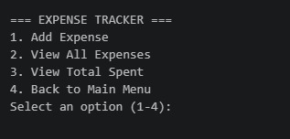
9. Screenshots:
screenshot 1:main page

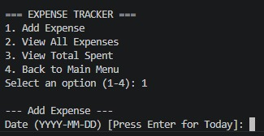
screenshot 2:add expense(Amount)


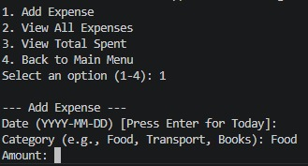
screenshot 3:add expense(Category)
screenshot 4:add expense(Amount)



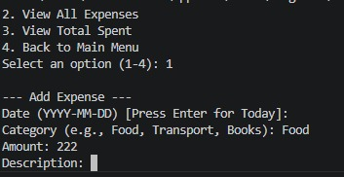
screenshot 5:add expense(Description)


screenshot 6:Expense added


screenshot 7:total expense view

screenshot 8:Full operation

10. Limitations and Possible Future Improvements

Limitations

- Command-line interface (CLI) only.

- Single-user application.

- Expense records cannot be edited or deleted after being saved.

- No graphical user interface (GUI).

- No charts or expense analysis features.

Possible Future Improvements

- Develop a graphical user interface (GUI) using Tkinter.

- Add user login and authentication.

- Use a database such as SQLite or MySQL instead of CSV files.

- Add options to edit and delete expense records.

- Generate monthly and yearly expense reports.

- Display expense statistics using graphs and charts.

- Add expense category filtering and searching.

- Export expense reports as PDF or Excel files.

